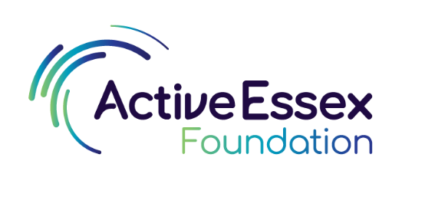
Sport and Youth Mental Health Project
Please complete at least one Young Person Pen Portrait per project. For multiple Pen Portraits, you can copy and paste the table in Section 2.
Once completed, please upload here: https://app.impactreporting.co.uk/pwa/5zv935
If you would prefer to complete paper copies, please use separate forms to complete multiple pen portraits and return them to sian.cleary@activeessex.org
SECTION 1: PROJECT INFORMATION
Name of organisation
Name of project
Project contact name and email address/phone number
SECTION 2: YOUNG PERSON PEN PORTRAIT
What is a Pen Portrait? A Pen Portrait describes the journey of a young person (participant or volunteer) who has been supported by your organisation. The boxes below are designed to capture the young person’s progression and the impact that your project is having.
If possible, include quotes from the young person.
Young Person Pen Portrait
Background | How did the young person initially become involved in the project? (e.g. who engaged them and how? referral, word-of mouth, signposted)  Before becoming involved in the project, what did they typically do in their spare time?
Why | What made them decide to start coming to your organisation?
Challenges | Did they face any initial challenges? (e.g. behaviour, engagement, attitude to physical activity, etc.)
What | How are they involved now?  Please provide details about the activities they participate in, their level of involvement/participation, changes in behaviour/attitudes, wellbeing, etc.
Plans for the future | What are their next steps/future plans?  If relevant, please include information about how the project has impacted the young person’s future plans regarding physical activity, education, volunteering, employment and aspirations.
Other materials | If appropriate, include photos and quotes (from the young person and/or the project lead) here.  If the young person does not want to be identified you could provide a group photo, a photo of the activity, or a photo of the facilities.

Note: Before sharing the Pen Portrait with Active Essex Foundation, you must explain to the young person that this information may be shared with our funders, used in reports, newsletters and/or publications, and/or shared on social media. Their name and any identifiable details will be removed before sharing.
The contents of this form must be signed off and approved by the relevant project lead and the individual. Parental consent must also be obtained for under 16s.

